Agreement on International Consortium *(Example)*

This agreement (hereinafter referred to as “Agreement”) is made and executed to establish an International Consortium (hereinafter referred to as “Consortium”) and utilize the Financing Programme for the project on CO2 emission reductions as “Synergistically Beneficial JCM Demonstration Programme by Ministry of the Environment of Japan*”*, which is referred to below.

Title of the project: ＿＿＿＿＿＿＿ (hereinafter referred to as “Project”)

Article 1 (Name of Consortium)

The Consortium consisted based on this Agreement shall be named ＿＿＿＿＿＿＿ project consortium.

Article 2 (Locations and names of participants)

This Consortium shall be consisted of Japanese participant(s) and foreign participant(s), as below.

1. Participant name  
   Address
2. Participant name  
   Address
3. Participant name  
   Address

Article 3 (Representative participant and co-participant(s))

The representative of this Consortium shall be a Japanese participant, and ___________ is hereby appointed. The other participants shall be co-participant(s).

Article 4 (Liabilities and authorities of the Representative Participant)

Regarding implementation of the Project, the Representative Participant of this Consortium shall be liable for all the operational management, including, but not limited to accounting, final examination of completion of the Project. The Representative Participant shall apply for and receive the fund provided through the Financing Programme facilitated by the Japanese government. Also it shall administer the property belonging to this Consortium.

2

Article 5 (Joint liabilities of participants)

1. Each participant of this Consortium shall strive for progress in its assignments and is jointly liable for implementation of the Project.

2. Each participant of this Consortium is also jointly liable for the following obligations listed as below;

(1) To cooperate with the Representative Participant in effective implementation of the Project and diffusion of the results in “Synergistically Beneficial JCM Demonstration Programme by Ministry of the Environment of Japan” under the responsibility of the Representative Participant.

(2) To manage the facilities and equipment introduced by the Project (hereinafter referred to as “Facilities”) with duty of diligence during the legal depreciation period as stipulated by the Japanese law in order to realize their efficient operation in accordance with the purpose of the Financing Programme even after the completion of the Project.

(3) To provide information about operating status and management of Facilities, effects of the Facilities in Greenhouse Gas (GHG) emission reductions and other information that are necessary to verify project results, when requested by Ministry of Environment, Japan (“MOEJ“) (including private entities which is consigned by MOEJ) or Global Environment Centre Foundation (“GEC”).

(4) To continue the above obligations from (1) through (3), even when changes of the participants are approved.

Article 6 (Implementation organization of this Consortium)

Implementation organization based on this Agreement shall be as referred to in the Appendix.

Article 7 (Effective period of this Agreement)

1. This Agreement comes into effect on ●● of __, 20YY and expires at the end of March of the last year of legal depreciation period as stipulated in the Japanese law.

2. The effective period of this Agreement set forth in the preceding article can be extended based on an agreement between the Representative Participant and the co-participant(s).

Article 8 (Management Committee)

This Consortium shall organize a management committee consisting of all the participants to manage the Project.

Article 9 (Responsible participant)

In this Consortium, the Representative Participant shall be the participant responsible for the Project and execute the authority to oversee and supervise the Project.

Article 10 (Persons in charge)

Representatives of the participants of this Consortium shall appoint a responsible person and/or persons in charge to engage in the Project under the Project Participants.

Article 11 (Liability of participant)

In the event that a participant of this Consortium causes damage to the other participants or a third party due to their fault related to implementation of the participant’s scope of the Project, the participant who caused the damage is liable.

Article 12 (Restriction of transferring rights and obligations)

All or part of the rights and obligations of this Agreement shall not be transferred or succeeded to a third party.

Article 13 (Confidentiality)

This Agreement is based on mutual consent among the participants of the Project and shall not be disclosed to any third parties.

Article 14 (Measures for bankruptcy and dissolution of participant during the Project)

If any of the participants goes bankrupt or is dissolved, the remaining participant shall jointly complete the scope originally assigned to the participant that goes bankrupt or is dissolved.

Article 15 (Defect liability after dissolution)

Even if any defect is found in the Project after the dissolution of this Consortium, each participant of this Consortium shall be jointly liable for the defect.

Article 16 (Matters not provided for in this Agreement)

Matters not provided for in this Agreement shall be determined by the Management Committee.

Article 17 (Ways to settle disputes and/or doubt)

If there is any dispute and/or doubt in the interpretation of this Agreement, the Representative Participant and the co-participant(s) shall consult with each other and attempt to settle the matter amicably.

5

In witness whereof, this Agreement has been made in ______ (_) originals and one copy and each participant shall place its signature and seals respectively thereon and retain the original. The copy shall be submitted to the GEC together with the Financing Programme

application form.

Date ● of ,~~2019~~20YY

Representative participant:

(Signature)

Name:

Title:

(Name of the Representative participant)

Partner participant(s):

(Signature)

Name:

Title:

(Name of the Partner participant)

(Signature)

Name:

Title:

(Name of the Partner participant)

Appendix: Implementation organization

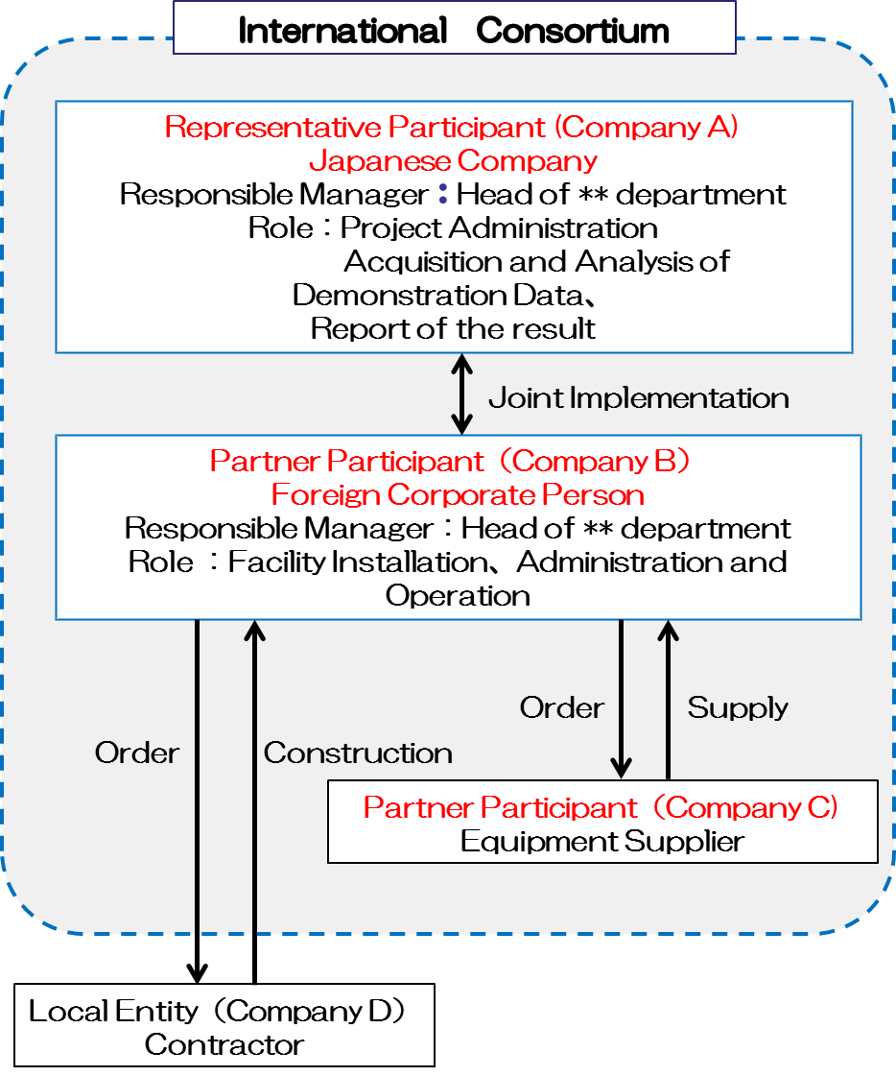

**（E社）**

**施工会社**

16