- 黄色マーカー箇所を変更してご提出ください。
- 共同事業者が2社以上の場合は、それぞれ作成ください。
- 本注意書きは削除してご提出ください。
AGREEMENT ON THE ALLOCATION OF JCM CREDITS

This Agreement on the Allocation of Joint Crediting Mechanism (hereinafter referred to as "JCM") Credits is signed on XX May 2023 by Project Participant A having its head office located at XXXX, and by Project Participant B having its head office located at XXXX, to determine the allocation of JCM credits.
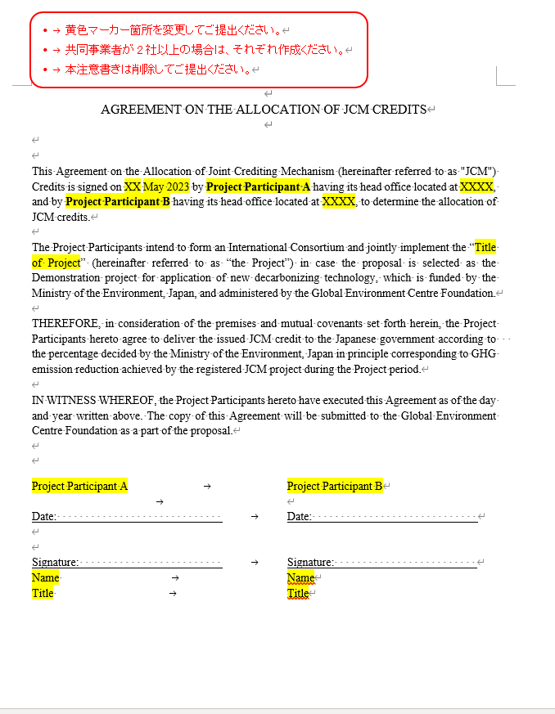
The Project Participants intend to form an International Consortium and jointly implement the “Title of Project” (hereinafter referred to as “the Project”) in case the proposal is selected as the Demonstration project for application of new decarbonizing technology, which is funded by the Ministry of the Environment, Japan, and administered by the Global Environment Centre Foundation.

THEREFORE, in consideration of the premises and mutual covenants set forth herein, the Project Participants hereto agree to deliver the issued JCM credit to the Japanese government according to the percentage decided by the Ministry of the Environment, Japan in principle corresponding to GHG emission reduction achieved by the registered JCM project during the Project period.

IN WITNESS WHEREOF, the Project Participants hereto have executed this Agreement as of the day and year written above. The copy of this Agreement will be submitted to the Global Environment Centre Foundation as a part of the proposal.

Project Participant A Project Participant B

Date: Date:

Signature: Signature:
Name Name
Title Title

