Agreement on International Consortium *(JCM Eco Lease Example)*

This agreement (hereinafter referred to as “this Agreement”) is made and entered into to compose an International Consortium (hereinafter referred to as “this Consortium”) and utilize the Financing Programme for the “Joint Crediting Mechanism (hereinafter referred to as "JCM Model Project 2023”).

Title of the JCM Model Project 2023: ＿＿＿＿＿＿＿ (hereinafter referred to as “the Project”)

Article 1 (Name of Consortium)

This Consortium consisted based on this Agreement shall be named ＿＿＿＿＿＿＿ project consortium.

Article 2 (Locations and names of participants)

This Consortium shall be consisted of a Japanese participant(s) and foreign participant(s) as below.

1. Participant name  
   Address
2. Participant name  
   Address
3. Participant name  
   Address

Article 3 (Representative Participant and co-participant(s))

The representative of this Consortium shall be a Japanese participant, and ___________ is hereby appointed. The other participants shall be co-participant(s).

Article 4 (Liabilities and authorities of the Representative Participant)

The Representative Participant of this Consortium shall be liable for purchase, installation, and commissioning of the facilities and equipment introduced by the Project (hereinafter referred to as “the Facilities”). Regarding implementation of the Project, the Representative Participant shall also be liable for operational management and accounting of the Project. The Representative Participant shall apply for and receive the fund provided through the Financing Programme facilitated by the Japanese government. Also, it shall administer the property belonging to this Consortium.

2

Article 5 (Joint liabilities of participants)

1. Each participant of this Consortium shall strive for progress in its assignments and is jointly liable for implementation of the Project.

2. Each participant of this Consortium is also jointly liable for the following obligations listed as below.

(1) To cooperate with JCM methodology developers by providing information required to develop a methodology applicable to the Project for Green House Gas (GHG) emission reductions utilizing the Facilities.

(2) To cooperate with Third Party Entities (TPEs) by providing materials and information required to efficiently conduct validation of the Project and verification of GHG emission reductions at the project site.

(3) To reduce, monitor and calculate amount of GHG emission utilizing the Facilities.

(4) To execute measurement and reporting on the effect of GHG emission reductions by the Facilities, and to report it to the Ministry of the Environment, Japan, annually until the end of the leasing period of the Facilities, that is ____ years for the Project.

(5) To take necessary actions such as application for the project registration by the Joint Committee set up by the governments of Japan and JCM partner-country.

(6) To request the Joint Committee to issue credits and deliver the issued JCM credit according to the percentage decided by the Ministry of Environment, Japan in principle corresponding to GHG emission reduction achieved by the registered JCM project during abovementioned leasing period to the Japanese government.

(7) In case information related to allocation of credit is stipulated in contracts of the Project, it shall not hinder observance of the rules of JCM between Japan and the partner country.

(8) To manage the Facilities with duty of diligence during the leasing period in order to realize their efficient operation in accordance with the purpose of the Financing Programme even after the completion of the Project.

(9) To continue the above obligations from (1) through (8), even when changes of the participants are approved.

Article 6 (Implementation organization of this Consortium)

Implementation organization based on this Agreement shall be as referred to in the Appendix.

Article 7 (Effective period of this Agreement)

1. This Agreement comes into effect on DD/MM/YYYY and expires at the end of March of the last year of the leasing period.

2. The effective period of this Agreement set forth in the preceding article can be extended based on an agreement between the Representative Participant and the co-participant(s).

Article 8 (Management Committee)

This Consortium shall organize a management committee consisting of all the participants to manage the Project.

Article 9 (Responsible participant)

In this Consortium, the Representative Participant shall be the participant responsible for the Project and execute the authority to oversee and supervise the Project.

Article 10 (Persons in charge)

Representatives of the participants of this Consortium shall appoint a responsible person and/or persons in charge to engage in the Project under the Representative Participant.

Article 11 (Liability of participant)

In the event that a participant of this Consortium causes damage to other participants or a third party due to their fault related to implementation of the participant’s scope of the Project, the participant who caused the damage is liable.

Article 12 (Restriction of transferring rights and obligations)

All or part of the rights and obligations of this Agreement shall not be transferred or succeeded to a third party.

Article 13 (Confidentiality)

This Agreement is based on mutual consent among the participants of the Project and shall not be disclosed to any third parties.

Article 14 (Measures for bankruptcy and dissolution of participant during the Project)

If any of the participants goes bankrupt or is dissolved, the remaining participants shall jointly complete the scope originally assigned to the participant that goes bankrupt or is dissolved.

Article 15 (Defect liability after dissolution)

Even if any defect is found in the Project after the dissolution of this Consortium, each participant of this Consortium shall be jointly liable for the defect.

Article 16 (Matters not provided for in this Agreement)

Matters not provided for in this Agreement shall be determined by the Management Committee.

Article 17 (Ways to settle dispute and/or doubt)

If there is any dispute and/or doubt in the interpretation of this Agreement, the Representative Participant and the co-participant(s) shall consult with each other and attempt to settle the matter amicably.

5

In witness whereof, this Agreement has been made in ______ (_) originals and one copy and each participant shall place its signature and seal respectively thereon and retain the original. The copy shall be submitted to Global Environment Centre Foundation (GEC) together with the Financing Programme application form.

Date DD/MM/YYYY

Representative Participant:

(Signature)

Name:

Title:

(Name of the Representative Participant)

Co-participant(s):

(Signature)

Name:

Title:

(Name of the Co-participant)

(Signature)

Name:

Title:

(Name of the Co-participant)

Appendix: Implementation organization

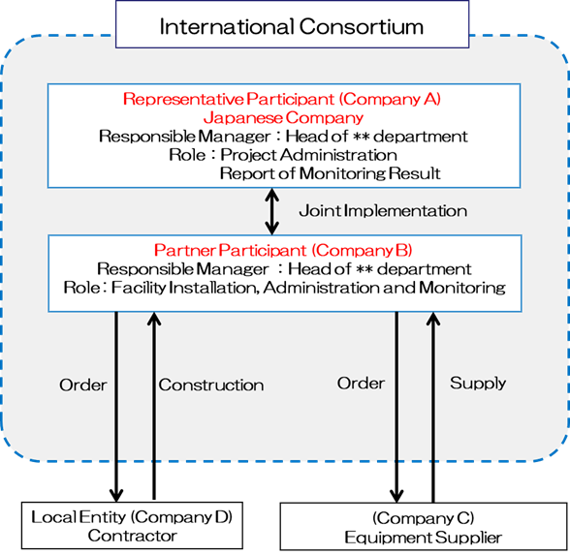

**（E社）**

**施工会社**

16