Project Idea Note for the JCM Model Project

Document release date | (DD/MM/YYYY)
Title of the proposed project
(should be self-explanatory and clearly indicate the activity leading to emissions reduction)
Host country
The main contact for the project  (for identification of the person in charge for the project in terms of communication) | Name of the contact entity (company, etc.):  Address of the contact entity:  Website of the contact entity:  Name and position of the main contact person in the entity:  E-mail of the main contact person:  Phone number of the main contact person:
Japanese participant[s] for the project and their roles in the project (if possible, please indicate the contact person of each entity involved in the project) | Name of the entity (company, etc.):  Roles of the entity in the project:  Address of the entity:  Website of the entity:  (Name and position of the contact person in the entity: )  (E-mail of the contact person: )  (Phone number of the contact person: )  Name of the entity (company, etc.):  Roles of the entity in the project:  Address of the entity:  Website of the entity:  (Name and position of the contact person in the entity: )  (E-mail of the contact person: )  (Phone number of the contact person: )  [please add other entities if necessary]
Participant[s] of host country for the project and their roles in the project (if possible, please indicate the contact person of each entity involved in the project) | Name of the entity (company, etc.):  Roles of the entity in the project:  Address of the entity:  Website of the entity:  (Name and position of the contact person in the entity: )  (E-mail of the contact person: )  (Phone number of the contact person: )  Name of the entity (company, etc.):  Roles of the entity in the project:  Address of the entity:  Website of the entity:  (Name and position of the contact person in the entity: )  (E-mail of the contact person: )  (Phone number of the contact person: )  [please add other entities if necessary]
Summary of the project
Example:
  - Objective of the project

  - Location of the project

  - Scale of investment including planned source of investment

  - Technology[ies] to be adopted for the project, and brief description of the technology[ies]

  - Project implementation scheme, and role of each participant

  - Status and progress of the project
Rough estimation of expected GHG emission reductions (unit: tCO₂/year)
Expected schedule up to the EPC completion and the registration under the JCM
Capacity building activity for the participant[s] of host country (cf. training on operation and maintenance of newly installed equipment, information sharing among stakeholders, organizing workshops, and/or study tour to Japan)

国際コンソーシアム体制図を添付してください。
Please insert an image of implementation structure.

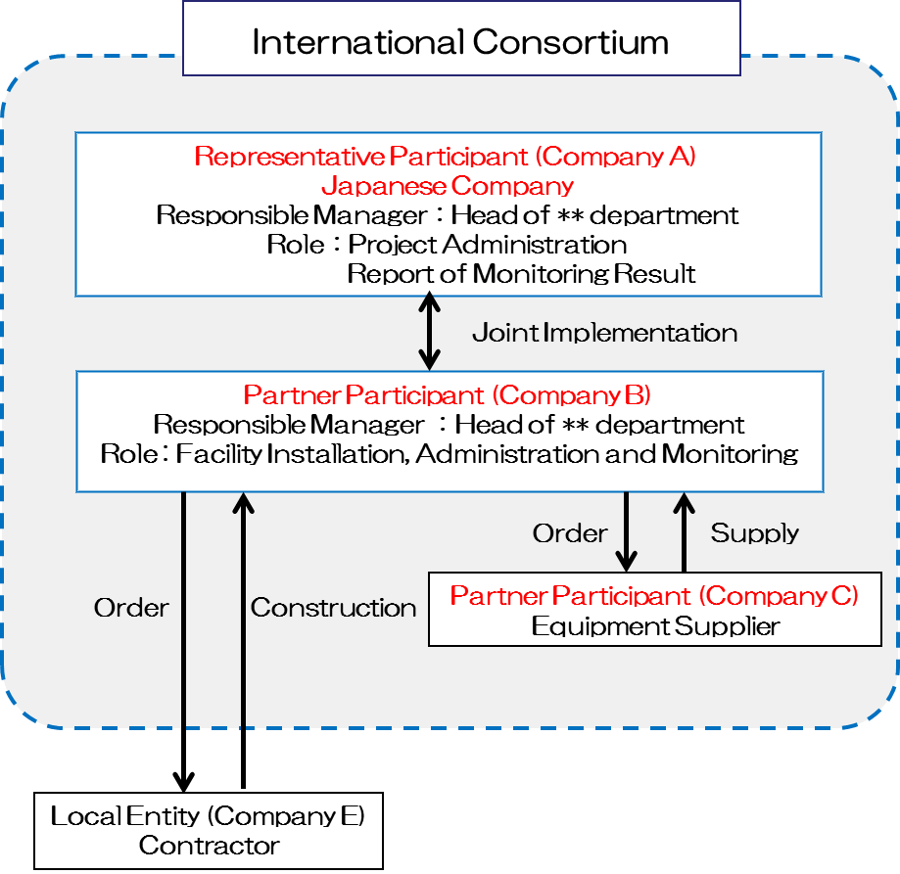
SAMPLE

