Agreement on International Consortium (Example)

This agreement (hereinafter referred to as “Agreement”) is made and executed to establish an International Consortium (hereinafter referred to as “Consortium”) and utilize the Financing Programme for the project on CO₂ emission reductions as “The Financing programme to Demonstrate Decarbonization Technology for Realizing Co-Innovation”, which is referred to below.

Title of the project: ＿＿＿＿＿＿＿ (hereinafter referred to as “Project”)

Article 1 (Appellation)
The International Consortium established based on this Agreement shall be termed ＿＿＿＿＿＿＿ project consortium.

Article 2 (Locations and appellations of constituent members)
This Consortium shall consist of a Japanese participant(s) and a partner-country participant(s), and the constituent members shall be as follows.

- Participant name
Address
- Participant name
Address
- Participant name
Address

Article 3 (Representative participant and partner participant(s))
The representative of this Consortium shall be a Japanese participant, and ___________ is hereby appointed. The other constituent members shall be a partner participant(s).

Article 4 (Liabilities and authorities of the representative participant)
The representative participant of this Consortium shall apply for the Project. Regarding implementation of the Project, the representative participant shall be liable for all the operational management, including, but not limited to accounting, final examination of completion of the Project. The representative participant shall apply and receive the financial support and also administer the property belonging to this Consortium.
2

Article 5 (Joint liabilities of constituent members)
1. Each constituent member of this Consortium shall strive for progress in their assignments and is jointly liable for implementation of the Project.
2. Each constituent member of this Consortium is also jointly liable for the following obligations of constituent members of the Project:
(1) To cooperate with the representative participant in effectively implementation of the project and diffusion of the results in the renovation and demonstration of leading low carbon/decarbonization technologies developed under the responsibility of the representative participant.
(2) To manage the facilities and equipment introduced by the Project (hereinafter referred to as “Facilities”) with due care as a vigilant manager within their legal durable years as stipulated by the Japanese law in order to realize their efficient operation in accordance with the purpose of the financial support even after the completion of the Project.
(3) To provide information about operating status and management of Facilities, ,effects of the Facilities in reduction of CO2 emission and other information that are necessary to verify project results, when requested by Ministry of Environment, Japan (“MOEJ“) (including private entities which is consigned by MOEJ) or Global Environment Centre Foundation (“GEC”).
(4) To obtain approval of GEC as to a replacement of a constituent member and to make such replacing member to fulfill the above obligations from (1) to (3),

Article 6 (Implementation structure of International Consortium)
Implementation structure based on this Agreement shall be referred to in the Appendix.

Article 7 (Terms of establishment and valid period of this Agreement)
1. This Agreement comes into effect on ●● of __, 2021 and expires at the end of Japanese fiscal year (March) during which the legal durable years of the Facilities, as stipulated in the Japanese law, have elapsed .
2. The valid period of this Agreement set forth in the preceding paragraph can be extended based on an agreement between the representative participant and the partner participant(s).

Article 8 (Steering Committee)
This Consortium shall organize a steering committee consisting of all the constituent members to manage the Project.

Article 9 (Project Supervisor)
In this Consortium, the representative participant shall serve as the project supervisor and as the authority overseeing and supervising the Project.

Article 10 (Persons in charge and engaged persons)
Representatives of the constituent members in this Consortium shall appoint a responsible person and persons in charge to engage in the Project under the project supervisor.

Article 11 (Several liability and role of the constituent members)
If a constituent member of this Consortium causes damage to the other members or a third party due to that member's fault related to implementation of the Project, the member is liable for the damage.

Article 12 (Restriction of transferring rights and obligations)
All or part of the rights and obligations conferred by this Agreement shall not be transferred or succeeded to a third party.

Article 13 (Confidentiality obligation)
The treatment of this Agreement shall be a matter of mutual consent among the constituent members of the Project and shall not be disclosed to any third parties.

Article 14 (Measures concerning bankruptcy or dissolution of the constituent members in the middle of the Project period)
If any of the constituent members becomes bankrupt or is dissolved, the remaining members shall jointly complete the task originally assigned to the member that becomes bankrupt or is dissolved.

Article 15 (Defect liability after dissolution)
If any defect is found in the Project after the dissolution of this Consortium, each constituent member shall be jointly liable for the defect.

Article 16 (Matters not provided for in this Agreement)
Matters not provided for in this Agreement shall be determined by the Steering Committee.

Article 17 (Solutions for disputes or doubts)
If there is any dispute or doubt in the interpretation of this Agreement, the representative participant and the partner participant(s) shall consult with each other and attempt to settle the matter amicably.
5

In witness whereof, this Agreement has been made in ______ (_) originals and one copy and each constituent member shall place their signatures and seals thereon, and retain the original. The copy shall be submitted to the GEC together with the grant application form.

Date ● of , 20192021
Representative participant:
(Signature)
Name:
Title:
(Name of the Representative participant)

Partner participant(s):
(Signature)
Name:
Title:
(Name of the Partner participant)

(Signature)
Name:
Title:
(Name of the Partner participant)

Appendix: Implementation structure

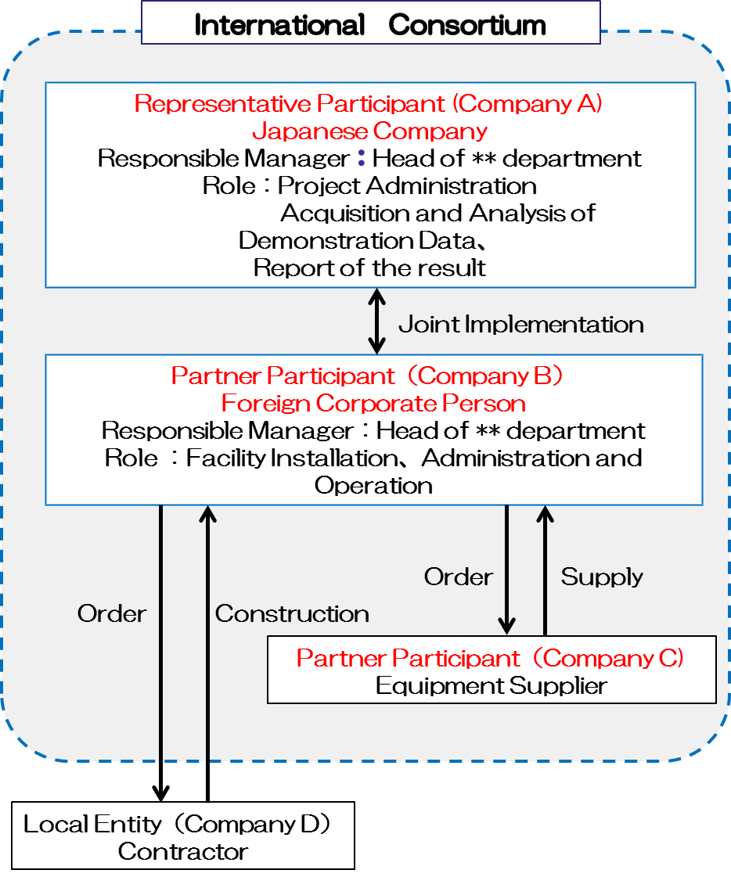
（E社）
施工会社
16

